**Topics: Descriptive Statistics and Probability**

1. Look at the data given below. Plot the data, find the outliers and find out $μ, σ, σ^{2}$

|  |  |
| --- | --- |
| **Name of company** | **Measure X** |
| Allied Signal | 24.23% |
| Bankers Trust | 25.53% |
| General Mills | 25.41% |
| ITT Industries | 24.14% |
| J.P.Morgan & Co. | 29.62% |
| Lehman Brothers | 28.25% |
| Marriott | 25.81% |
| MCI | 24.39% |
| Merrill Lynch | 40.26% |
| Microsoft | 32.95% |
| Morgan Stanley | 91.36% |
| Sun Microsystems | 25.99% |
| Travelers | 39.42% |
| US Airways | 26.71% |
| Warner-Lambert | 35.00% |

Ans) to find outliers boxplot is more efficient

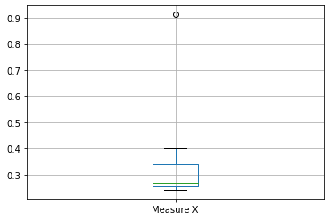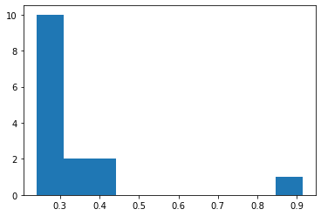

From the boxplot we can say that the outlier present at upper quartile

And the Morgan Stanley is the outlier value is 0.9136

Mean - µ = 0.332713, standard deviation $σ$ = 0.169454, variance $σ^{2}$ = 0.0287

2.

Answer the following three questions based on the box-plot above.

1. What is inter-quartile range of this dataset? (please approximate the numbers) In one line, explain what this value implies.  
   Ans) Q1 = 5, Q3= 12 so the median falls at median = 7 ,  
   IQR = Q3-Q1 🡺12-5🡺7   
   7 is the inter-quartile range

Lower extreme /min = Q1 -1.5*7🡺5-10.5🡺-5

Upper extreme /max = Q3 +1.5*7🡺12+10.5🡺22.5

1. What can we say about the skewness of this dataset?

Ans) as the median 7 is near to the lower quartile Q1 so it is positively skewed

1. If it was found that the data point with the value 25 is actually 2.5, how would the new box-plot be affected?  
   Ans) even if the value is 2.3 it lies under lower extreme (-5) to Q1 (5) value which is 0 to 25% so box-plot will not be affected .



Answer the following three questions based on the histogram above.

1. Where would the mode of this dataset lie?  
   Ans) 4-6 and 6-8 ,2 hist have same frequency of 20, so the mod lies within these ranges
2. Comment on the skewness of the dataset.  
   Ans) from the hist we can say the peak at left and tail prolonged to the left so it is positively skewed dataset.
3. Suppose that the above histogram and the box-plot in question 2 are plotted for the same dataset. Explain how these graphs complement each other in providing information about any dataset.   
   Ans) both data plots shows the data is slightly skewed to the right as positively skewness ,as data spread more towards upper quartile range and the outliers present at upper extreme in boxplot/right tail end in histogram and

2.AT&T was running commercials in 1990 aimed at luring back customers who had switched to one of the other long-distance phone service providers. One such commercial shows a businessman trying to reach Phoenix and mistakenly getting Fiji, where a half-naked native on a beach responds incomprehensibly in Polynesian. When asked about this advertisement, AT&T admitted that the portrayed incident did not actually take place but added that this was an enactment of something that “could happen.” Suppose that one in 200 long-distance telephone calls is misdirected. What is the probability that at least one in five attempted telephone calls reaches the wrong number? (Assume independence of attempts.)  
  
Ans) n= 5 , probability of call misdirecting p = 1/200, probability of call not misdirecting q= 1- 1/200🡺199/200

Probability of at least 1 in 5 attempts call misdirecting p(x)= 1 –🡺1-0.9752🡺0.0248

1. Returns on a certain business venture, to the nearest $1,000, are known to follow the following probability distribution

|  |  |
| --- | --- |
| x | P(x) |
| -2,000 | 0.1 |
| -1,000 | 0.1 |
| 0 | 0.2 |
| 1000 | 0.2 |
| 2000 | 0.3 |
| 3000 | 0.1 |

1. What is the most likely monetary outcome of the business venture?  
   Ans) the probability 2000 is (0.3 ) is more comparing to others
2. Is the venture likely to be successful? Explain  
   Ans) E(x) *= $\sum_{all x}{x p(x)}$*= (-2000*0.1) +(-1000*0.1) +(0) +(1000*0.2) +(2000*0.3) +(3000*0.1) = 800 as average gives a positive number venture likely to be successful
3. What is the long-term average earning of business ventures of this kind? Explain  
   Ans) E(x) *= $\sum_{all x}{x p(x)}$*= (-2000*0.1) +(-1000*0.1) +(0) +(1000*0.2) +(2000*0.3) +(3000*0.1) = 800

What is the good measure of the risk involved in a venture of this kind? Compute this measure  
  
Ans) the standard deviation gives the measure of risk involved ,lower the std value higher the risk   
the value is 1707.825127659933 , the the value is higher so risk is lower